Unlocking Landscapes: The inclusive role of sensory histories of people and place

Clare Hickman and Sarah Bell, September 2022
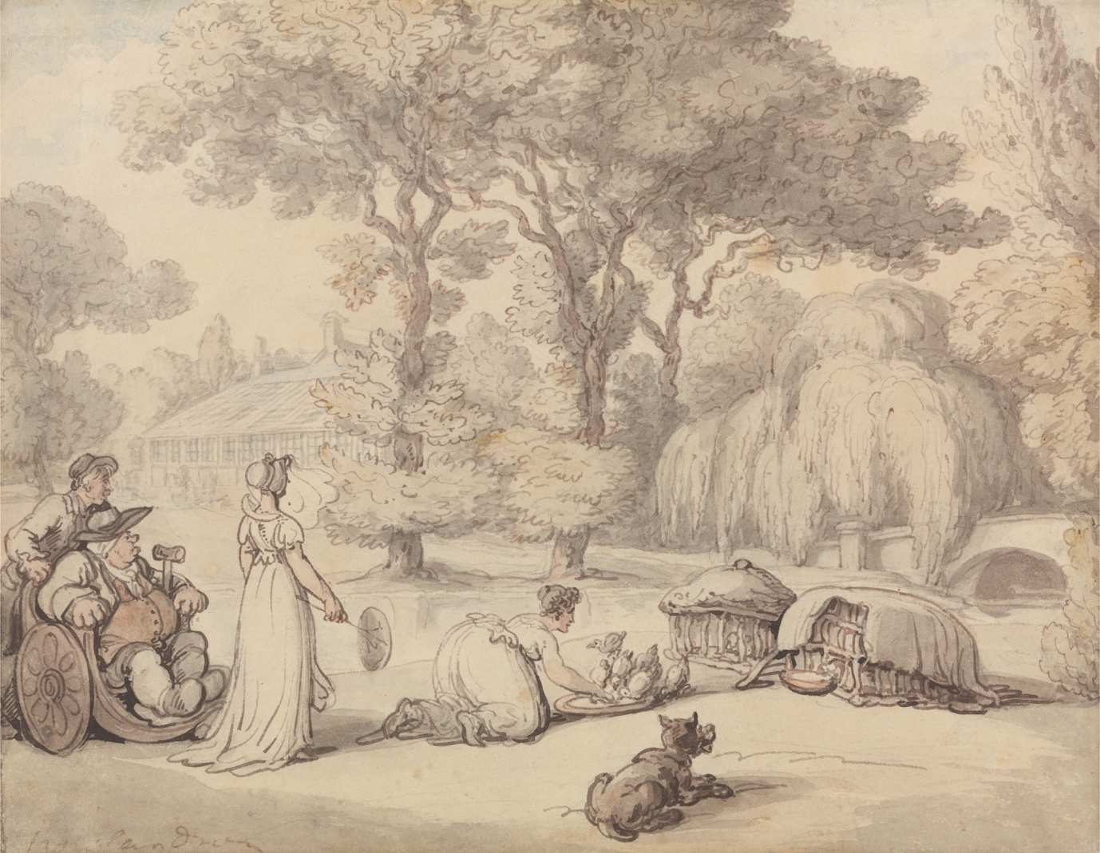

Figure 1: Thomas Rowlandson, 1756–1827, British, ‘Feeding the Ducklings’, undated, Watercolour with pen and brown ink over graphite on medium, slightly textured, cream, wove paper, Yale Center for British Art, Paul Mellon Collection, B1981.25.2676.

Contents

Summary 3
Introduction 5
What is a historic landscape? 5
Whose (historic) landscape? 6
Social history and the landscape 7
Change over time – Climate, adaptation, transformation 10
Finding past sensory narratives 11
Using sensory narratives to tell new stories in different ways 13
Guiding questions for future work 22
Acknowledgements 23
References 25

Summary
This report summarises themes we have been exploring as part of the AHRC funded network, ‘History, Culture and Sensory Diversity in Landscape Use and Decision Making’ (2020-2023). It foregrounds the potential for sensory history scholarship to disrupt and expand the types of stories shared about landscape; moving beyond dominant forms of landscape encounter and enabling a greater diversity of people to ‘be’ and belong in historic landscapes. This report is intended for anyone involved in the management and interpretation of such landscapes.
The European Landscape Convention (2000) defines 'landscape' as 'an area, as perceived by people, whose character is the result of the action and interaction of natural and/or human factors'. In this report, we are predominately concerned with historic landscapes that have a designed element and that have a contemporary leisure use; from country estate gardens, through public parks and arboretums, to places of industrial heritage, and national trails. However, there are many other places that have historical and cultural meanings for which the insights shared could still be considered.
Moving away from prominent ocular-centric approaches, the interpretation of historical landscapes could be reconsidered by drawing on multisensory place stories; how and why the sounds, scents, textures and broader sensations of embodying the landscape may have changed through history, and how these experiences may have varied amongst different types of inhabitants (human or otherwise). The focus on ‘stories’ rather than ‘story’ is key as there are many, often overlapping narratives, which can speak to similarly diverse landscape visitors, makers and shapers.
Another way to improve the range of narratives about landscapes and landscape experiences would be to include accounts from often overlooked groups such as foresters, labourers, and gardeners – those materially tasked with shaping the land. Although this can be challenging with the limited nature of primary source material, even limited snapshots that acknowledge hidden or unnoticed labour in the making, remaking and maintenance of landscapes would help raise the significance of such roles within landscape history.
The temporalities of the stories told about landscape are also important. Climate change is impacting – and will continue to impact – on landscapes with both personal and cultural value. Can we look to landscape histories to emphasise the dynamic qualities of landscape through the stories told, finding ways to resist disempowering anxious logics of change in these settings, and to continue to care for and nurture such landscapes as they evolve in the face of change?
Although the report calls for more attention to a range of landscape histories, we are not suggesting the answer lies solely in more written text and interpretation boards. Over-reliance on the written word can reinforce privileged experiences and ways of perceiving places, and limit experiential and embodied ways of sensing, knowing, imagining and understanding landscape that are just as important. Rather, we encourage a mediation of these landscape histories though innovative, artistic and embodied approaches that complement yet move beyond an intellectual understanding through the written word.

Introduction
This report summarises themes we have been exploring as part of the AHRC funded network, ‘History, Culture and Sensory Diversity in Landscape Use and Decision Making’ (2020-2023). Through network activities, we have been reflecting on opportunities to complement UK landscape management and decision-making approaches that foreground biodiversity with a focus on human diversity. Here, we demonstrate the potential for sensory history scholarship to disrupt and expand the types of stories shared about landscape; moving beyond dominant forms of landscape encounter and enabling a greater diversity of people to ‘be’ and belong in historic landscapes. This report is intended for anyone involved in the management and interpretation of such landscapes.
The image on the front of this report – Thomas Rowlandson’s depiction of a Regency garden scene – includes several elements that are often overlooked when such places are described by historians and others now. The first thing to note is the garden being used by people, presumably from the emerging middle class, for both pleasure and production. The second is the depiction of the gentleman in the bathchair with a crutch who is watching the feeding of the ducklings along with someone who has joined him to watch (and is assisting in pushing the chair). We should also note the birds which are part of the garden scene and a key part of the experience. Finally, there is the humour in this story as the dog looks hungrily at the other duckling cage hoping he will be fed too!
Rowlandson has portrayed a group of people enjoying the experience of interacting with the garden – including its human and non-human inhabitants – thereby drawing us in to the scene. This watercolour provides an engaging lens into how these gardens were used and by whom. Although it is a visual source and not linked to a specific place, it is the kind of material which could be combined with descriptions of the sounds of the ducklings and the dog, and maybe the scents of the plants, to engage visitors with gardens today via a sensory, creative and potentially playful narrative about the people who used these places in the past.

What is a historic landscape?
The European Landscape Convention (2000) defines 'landscape' as 'an area, as perceived by people, whose character is the result of the action and interaction of natural and/or human factors'. For this report we are predominately concerned with historic landscapes that have a designed element and that have a contemporary leisure use; from country estate gardens, through public parks and arboretums, to places of industrial heritage, and national trails. However, there are many other places that have historical and cultural meanings for which the insights shared within this document could still be considered.
Each landscape has specific histories and cultural meanings for diverse groups. This report does not suggest a one size fits all approach to thinking about the uses and applications of sensory histories. Rather, it shares suggestions and seeks to provoke ideas that could be developed in ways that are relevant to the specific histories, fabric and uses of individual sites. We take a broad view of human and non-human interactions with historic places, moving beyond a predominant concern with the visual and statically ‘looking’ at the scenery to consider the other senses; scent, sound, touch and feel, as well as movement through the landscape, both in the past and the present.
‘Landscape’ (like wilderness) is a problematic term. As scholar Laura Menatti has argued, ‘the reduction of landscape to a scenery and its beauty is neither a coincidence nor a novelty in modern thought. On the contrary, it is a problematic heritage of the modern characterisation of the term in the Western world as a beautiful view.’ The definition offered by the Oxford English Dictionary (OED) is highly ocular-centric: ‘A picture representing natural inland scenery, as distinguished from a sea picture, a portrait, etc. originating from the 1600s’. From this definition, we can glean the influence of art, particularly painting, as a way of imagining and reading landscapes. Yet this was not always the case. As noted by anthropologist Tim Ingold, ‘landscape’ originally referred to early medieval practices of working and living with the land, with the old English word ‘sceppan’ or ‘skyppan’ meaning ‘to shape’. In the seventeenth century, this was conflated with the Greek work ‘skopos’ (to look), informing enduring visual landscape preoccupations. Perhaps it’s time to return to ideas of shaping and embodying the land rather than simply ‘reading’ it from afar.

Whose (historic) landscape?
Moving away from the pictorial, one way to rethink historical landscapes is to consider multisensory place stories. The focus on ‘stories’ rather than ‘story’ is key as there are many, often overlapping narratives, which can speak to similarly diverse landscape visitors, shapers and inhabitants. As civil rights activist, Grace Lee Boggs, wrote: ‘History is not the past. It is the stories we tell about the past’. She went on to argue that it is also important to consider ‘how’ we tell these stories. Indeed, stories can ‘bring us together and teach us about the world; yet they are also the things that break us apart and make us invest in ways of being that are destructive to each other and to the world’. The crafting and telling of stories around landscape histories therefore need research, care and thought.
This approach has been effectively utilised by the historian Steve Poole, in conjunction with the Holburne museum in Bath and an experience design organisation, with their ground-breaking ‘Ghosts in the Garden’ project. Here they used Special Listening devices and a choose-your-own-adventure game experience based on in depth archival research to help visitors tune into the past using audio narratives. As Poole notes, their intention was to:
[…] suggest to visitors that a place has many histories and that our understanding of it is influenced by a process of narrative selection. The essential proposition was that quotidian stories and characters from the historical record can be as engaging to audiences as stories about celebrities and social elites because they reflect more closely the life experiences of modern garden visitors.
People experiencing these places also come with their own stories, so we perhaps need to ask how might we connect those stories to those of people and places in the past? Can we tell more diverse stories of those who have worked in and visited places, alongside the more commonly told stories of owners and designers?

Social history and the landscape
One way to improve the range of narratives about landscapes and landscape experiences would be to include accounts from often overlooked groups such as foresters, labourers, and gardeners – those materially tasked with shaping the land. The limited nature of primary source material does make reconstructing their impact a challenge. As Carole O’Reilly notes in her recent work on parks:
[…] any discussion of the staff of the public park is hampered by […] a corresponding lack of material emanating from the gardener and the labourer. The accounts of park-keepers are similarly rare. Thus, any attempt to tell the story of the parks’ employee is limited.
However, even limited snapshots that acknowledge the often hidden or unnoticed labour in the making, remaking and maintenance of landscapes would help raise the significance of such roles within landscape history. This would also help develop discussions of human-nature relationships and how these have always been intertwined; countering artificial binaries between ‘natural’ and ‘unnatural’ landscapes. As noted further below, such efforts are also important in relation to future change and adaptation within the landscape in relation to the climate crisis.
Similarly, there are growing moves to recognise the colonial histories of many nationally celebrated landscapes (and their co-constituents i.e., plants gathered from other parts of the world) in how they are shared and interpreted. For example, curators Subhadra Das and Miranda Lowe have explored the important and engaging stories that have been lost and obscured in the interpretation of natural history collections, including the knowledge and skills of enslaved and indigenous people in relation to plant collecting. At the same time as uncovering these histories, we need to think about how we can best share them with wider audiences. Many important discussions around contested landscape histories become confrontational (overtly or softly) and fracture very quickly, particularly in the current polarising political climate where exclusionary lines continue to be drawn around aspects of nationhood, national identity and citizenship. This raises the question of how to enable and encourage non-violent empathetic discussion in ways that promote constructive engagement with a wide range of audiences? Moving away from preoccupations with the visual qualities of landscape – and the (often power-laden) ‘Western’ visual gaze – might help move beyond particular cultural ideas of what constitutes the ‘natural’ and ‘beautiful’ which can also be exclusive to particular social and cultural groups.
Along the same lines it is important to ask what or whose stories are omitted altogether? One example is the seeming lack of disability history or heritage studies related to historic landscape design and use in the UK. Yet, renowned eighteenth-century landscape gardener, Humphry Repton, was one of the first to develop raised beds for gardening following a disabling coach accident, and British horticulturalist, Gertrude Jekyll, moved into garden design from her work as an artist and craftswoman, with the onset and progression of sight impairment.
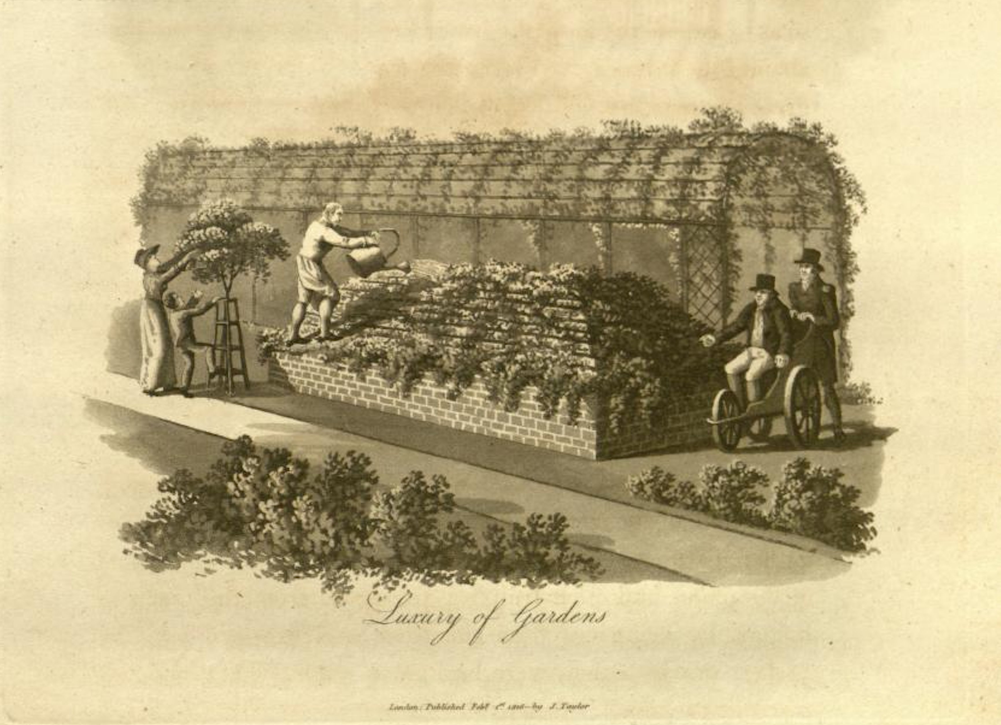
Figure 2: Humphry Repton directing gardeners from his bathchair, Fragments on the Theory and Practice of Landscape Gardening, 1816, p. 183. Credit: Biodiversity Heritage Library

Efforts are already being made in the US to explore this area further with a project across the National Parks Service, albeit primarily focused on institutional history. The example of their work at the Home of Franklin D. Roosevelt National Historic Site, better known as Top Cottage – where ramps, hand rails and other material features are given historic importance – gives a clear indication of how such elements might be used to demonstrate histories of adaptation and use in the past. These features can also open up discussions around disability stigma and the hiding of perceived physical impairments: https://www.historians.org/publications-and-directories/perspectives-on-history/november-2018/disability-and-place-interpreting-accessibility-at-fdrs-home What other stories might the archives tell us if we only look for them?

Change over time – Climate, adaptation, transformation
Scholar, Veysel Apaydin, argues that “the focus of those who understand and develop cultural heritage has shifted somewhat, from highlighting issues of conservation to highlighting issues of change.” A key role for landscape histories during this time of rapid change and adaptation is to give a clear sense of temporal context and point to periods of environmental and social change in the past. There is perhaps a need to challenge some of the ideas of unchanging ‘treasured’ landscapes, and to reflect on how human involvement is an integral part of the past, present and future of landscape use.
As Tom Williamson has written in relation to woodlands, “ancient woods are often thought of as the most natural of our habitats, fragments of the original forests which once covered the country – islands of preservation. But they are, perhaps, better considered as factories for the production of wood and timber which have, for the most part, become derelict. Their flora and fauna have been shaped in critical ways by this history”. A deeper understanding of this entwined human and nonhuman landscape history allows us to see a rich human past in what are otherwise often considered ‘natural’ 'untouched' settings – a deceptive framing that is also relevant to the future of landscapes. For example, in relation to aspirations for rewilding, Williamson states: “in an important sense ‘rewilded’ reserves would still be cultural landscapes, for the motley array of plants and creatures living within them would represent a dim memory of specifically human actions and desires, ranging from medieval hunting fashions to Victorian gardening fads. They would still have a history.”
The temporalities of the stories told about landscape are important. There are times and places where stories of transformation are helpful, and others where stories of longevity and stability may be more appropriate. How can we better understand the ways in which the landscapes we encounter now were imposed and imprinted on potentially very different landscapes in the past? What are the implications of that for how those landscapes become coded and used? How can we bring to life the landscapes that existed before their current form? At the time of writing, the world is at 1.1°C above pre-industrial temperatures. Many of our ecological systems are already approaching hard limits to adaptation with some changes likely to be irreversible. This will impact on landscapes with both personal and cultural value even with ongoing climate mitigation efforts. Can we look to landscape histories to emphasise the dynamic qualities of landscape through the stories told, finding ways to resist disempowering anxious logics of change in these settings, and to continue to care for and nurture such landscapes as they evolve in the face of change?

Finding past sensory narratives
“Most sensory historians agree there has been an overemphasis on sight in the writing of history, with much of what is recorded in images and texts preserving visual impressions.” This statement from historians Hardy and Cushing is key to thinking about what happens in the process of writing and disseminating history. Here there is a need to go back to basics and ask what are the other histories that can be told from the archives? If we go into primary sources looking for records of smells, sounds, tastes etc., might we find something different to the usual visual based narratives?
There are many different kinds of archives and sources but there are some which are more likely to give these accounts than others – letters, diaries, account books etc., can be used where they exist. These sources may foreground more elite voices but they might still help bring the past to life in multisensory and playful ways.
In other places it might be a case of conducting oral histories and interviews to gain a greater insight into people’s broader sensory relationship with places, even in the more recent past. As oral historian Holly Werner-Thomas has recently argued, approaches such as the use of ‘sensory roadmaps’ in oral history are useful because they place “value on the seemingly insignificant, for descriptive detail brings listeners and readers closer to events imbued with emotion and perspective that have the power to teach us about lived experience”. Such approaches can surely be used to create new connections between the past and the present that can highlight alternative meanings and human-environment inter-relationships.

Case Study: Mrs Delaney’s letters
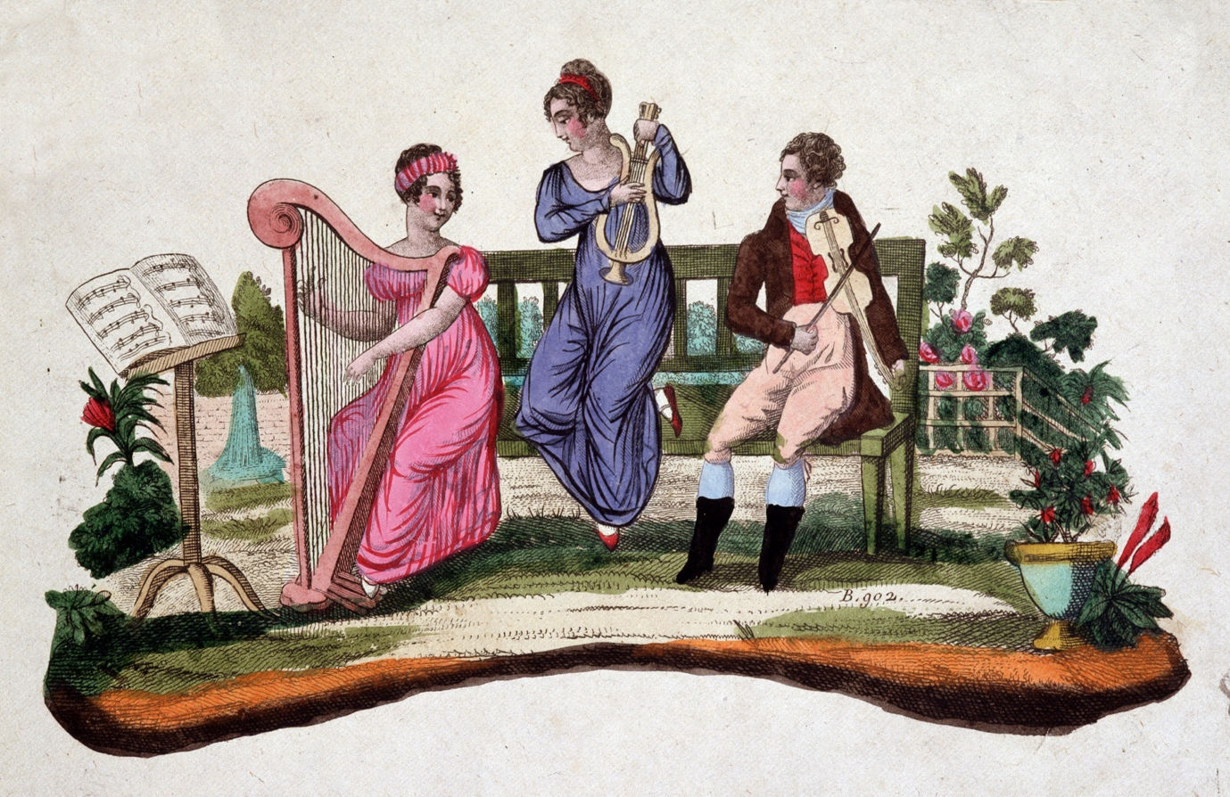
Figure 3: Three people playing musical instruments in a garden: harp, lyre, viola. Etching sd. of the eighteenth century. Photo © Leonard de Selva / Bridgeman Images

These are just a few examples from the letters of Mrs Delaney (an elite eighteenth-century woman who visited gardens and made expert botanical collages) which demonstrate the sensory descriptions, activities within the landscape and also some of the playful qualities of being in these spaces.
My garden is at present in the high glow of beauty, my cherries ripening, roses, Jessamine and pinks in full bloom, and the hay partly spread and partly in cocks, complete the rural scene. We have discovered a new breakfasting place under the shade of nut-trees, impenetrable to the sun’s rays, in the midst of a grove of elms, where we shall breakfast this morning; I have ordered cherries, strawberries and nosegays to be laid on our breakfast-table, and have appointed a harper to be here to play to us during the repast, who is to be hid amongst the trees. Mrs Hamilton is to breakfast with us, and is to be cunningly led to this place and surprised. (Delville), Mrs Delany to Mrs Dewes, 22 June 1750
It has been a charming day, and the field below my garden has exhibited a busy scene of haymakers and a grateful smell of hay. (Glan Villa), The Hon Mrs Boscawen to Mrs Delany, 2 August 1779.
There is a gravel walk from the house to the great lake fifty-two feet broad, and six hundred yards long. The lake contains 26 acres, if of an irregular shape, with a fort built in all its forms; there are islands in the lake for wild fowl, and great quantities of them that embellish the water extremely. I never saw so pretty a thing. There are several ships, one a complete man-o-war. My godson is governor of the fort, and lord high admiral; he hoisted all his colours for my reception, and was not a little mortified that I declined the compliment of being saluted from the fort and ship. (Dangan, Ireland), Mrs Delany to Mrs Dewes, 15 October 1748.

In 2016, Linden Groves of The Gardens Trust and Clare Hickman used these accounts, as well as a range of other primary sources, to create a digital prototype exploring how such narratives might help today’s historic garden visitors to engage with these places. You can find out more about the project online: http://www.experiencingarcadia.org/
If explored with care, there are opportunities at the intersection of digital and sensory history approaches to provoke new forms of landscape engagement. As Steve Poole argues, ‘the question we should be asking in this regard is not “how can we use mobile and digital technologies to get larger and more diverse audiences through the door?”, but “how can we use mobile and digitally enhanced forms of interpretation to change the questions we ask and the ways in which we engage with historic sites?”’

Using sensory narratives to tell new stories in different ways
Although this report calls for more attention to a range of landscape histories, we are not suggesting the answer lies solely in more written text and interpretation boards. Over-reliance on the written word can reinforce privileged experiences and ways of perceiving places, and limit experiential and embodied ways of sensing, knowing, imagining and understanding landscape that are just as important. Landscapes are already multisensory places so rather than simply making special sensory artefacts to be engaged with (which is common practice in the museum sector) or creating distinct sensory gardens, there is scope to draw out the rich multisensory embodied experience of simply moving through a landscape in different ways and at different times.
There is also promise in co-creating safe, welcoming spaces on site for people who might not usually feel at home in a landscape to explore and reflect on their histories and experiences of landscape connection (or disconnection), and to story and share these experiences through varied mixed media forms. Reflecting the potential for carefully curated stories to inform social change and expand ‘possibilities for living in/with difference’, people can claim space through creative efforts to disrupt and reimagine orientations to difference and ‘move past the single story that collapses the diversity of experience and replace it with a multiplicity of stories’.
As scholar, Jenni Lauwrens, writes in relation to art history: “by encouraging audiences to participate in the work, thereby breaking down physical barriers normally associated with the rational observer of visual art, not only is the hegemony of sight overturned, but the possibility of a detached subject is subverted, as artists dethrone seeing from its privileged position in the sensual body”. This can similarly be applied to thinking about how we encourage people to engage with landscapes and their histories. As she continues: “an aesthetics of embodiment would acknowledge the audience’s bodily participation in works of art, which includes memories, beliefs and attitudes mediated through the body.” Perhaps we can also encourage a mediation of the past history of landscape though innovative and artistic approaches which evoke a greater embodied approach rather than just an intellectual understanding through the written word.

Case Study: Sensory Trust – Engaging with historic landscapes in and through the body
Sensory Trust is an organisation that uses an inclusive, multisensory approach to connect people with place. They believe that sensory experiences connect people at a deeper level with a place and create stronger, longer-lasting memories. Through working with a wide diversity of people, they have found that senses such as touch and smell often provide the most profound and memorable experiences. People who do not use sight as a primary sense are often much more aware of the wider network of interpretive senses that are so important in how people experience a historic landscape.
We all interpret the world though our senses, everything we interpret and take in, and everything we communicate out is done through our senses. To each of us this will be working differently, we are all unique when it comes to the way our senses work, whether hypersensitive to some, under stimulated in others or somewhere in the middle. We each engage through our senses and need the world to give us that sensory feedback so we can fully participate. This is true when it comes to landscapes, you must fully take them in through all your senses. It is not enough just to look at a framed representation of it. You need to be in it, be part of it, to breathe it in and feel it. (Lynsey Robinson, Sensory Trust 2022)

Sensory Trust’s work explores how to ensure this approach can happen in our historic landscapes. There is an important first step in considering the range of senses that are being stimulated and if there is something for everyone, no matter how distinct each person’s palette of senses may be. This is coupled with the question of whether the experiences on offer are inclusive and meeting the needs and wishes of a diverse audience.
Some of the sensory techniques that are used appear deceptively simple, even though they are the result of extensive research and development processes. This is important as they need to be easy and inviting for people to engage with.
Identifying sensory opportunities
Historic landscapes are rich in sensory opportunities and each place will have a unique set of sensory highlights. The challenge is to find these and tease them out. This is where sensory mapping is so effective, a technique developed many years ago by Sensory Trust.
Sensory mapping is a simple, flexible technique to identify sensory highlights with a view to creating inclusive and engaging visitor experiences. It has proved effective in all types of landscape as a way of encouraging people to ‘see’ a landscape in new ways. The most successful application has been by inviting different community groups to join a sensory mapping exercise. This involves identifying interesting sensory rich highlights and recording the responses. It can focus on one or two specific senses to start with, for example looking for just colours and textures. Sometimes this organically expands as people notice other things; intriguing textures, pungent smells or no scent at all, changes in temperature, and different sounds.
After using sensory mapping in historic landscapes, managers have said “I have never seen my place in this way before, I feel like I have discovered it in a new way”. (Historic park manager, sensory mapping participant)

Figure 4: Sensory mapping training at Golitha Falls. Photo ©Sensory Trust

Encouraging sensory exploration
Trail markers are a good example that Sensory Trust uses to direct attention to sensory highlights in a landscape.
The simple act of putting out a marker with the symbol of a nose on it communicates many things: it tells someone that there is something here that smells, it says that you want them to smell it, that there may be other things around and that they should be getting up close and taking a sniff. If the marker also has strong contrasting colours, raised tactile outlines and even some Braille with the word smell, it has gone even further in widening communication. It is now communicating that you expect there to be people who are blind or partially sighted visiting this space, that you want them to have a full participatory experience and that they are most definitely welcome here.
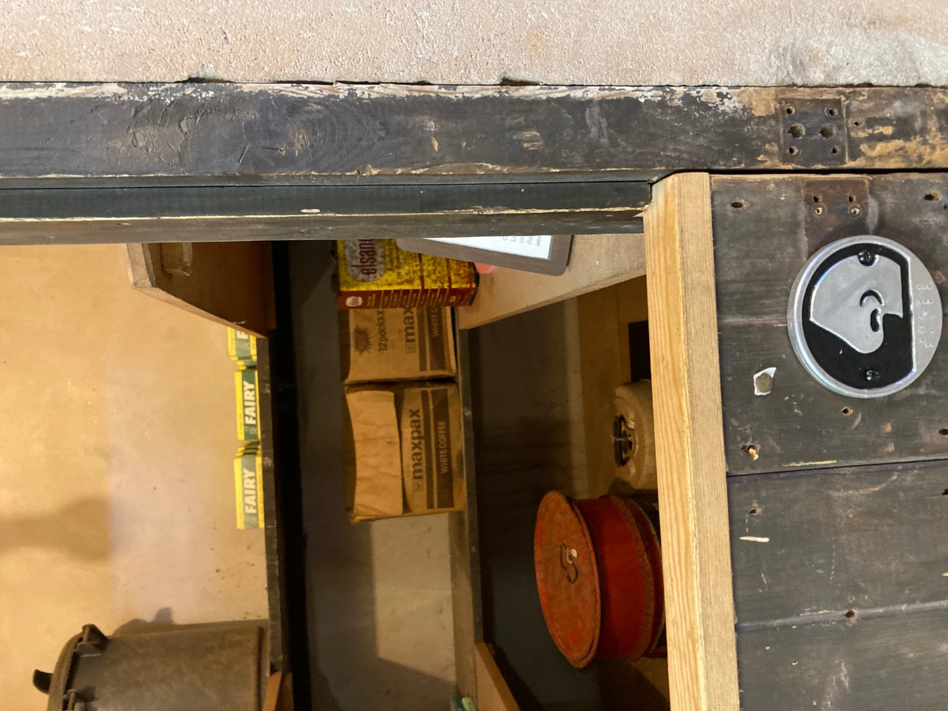
Figure 5: Photo of a sensory smell marker with braille. Photo ©Sensory Trust

Another marker, another sense, this one with a hand on it representing touch. Touch is one of the most important senses. It is only through touch that we can know the substance of something, how it feels, what it weighs. In the same way, this is further encouragement to be touching what is here in this space, to be exploring through our sense of touch, willing someone to take all of this in with each of their senses.
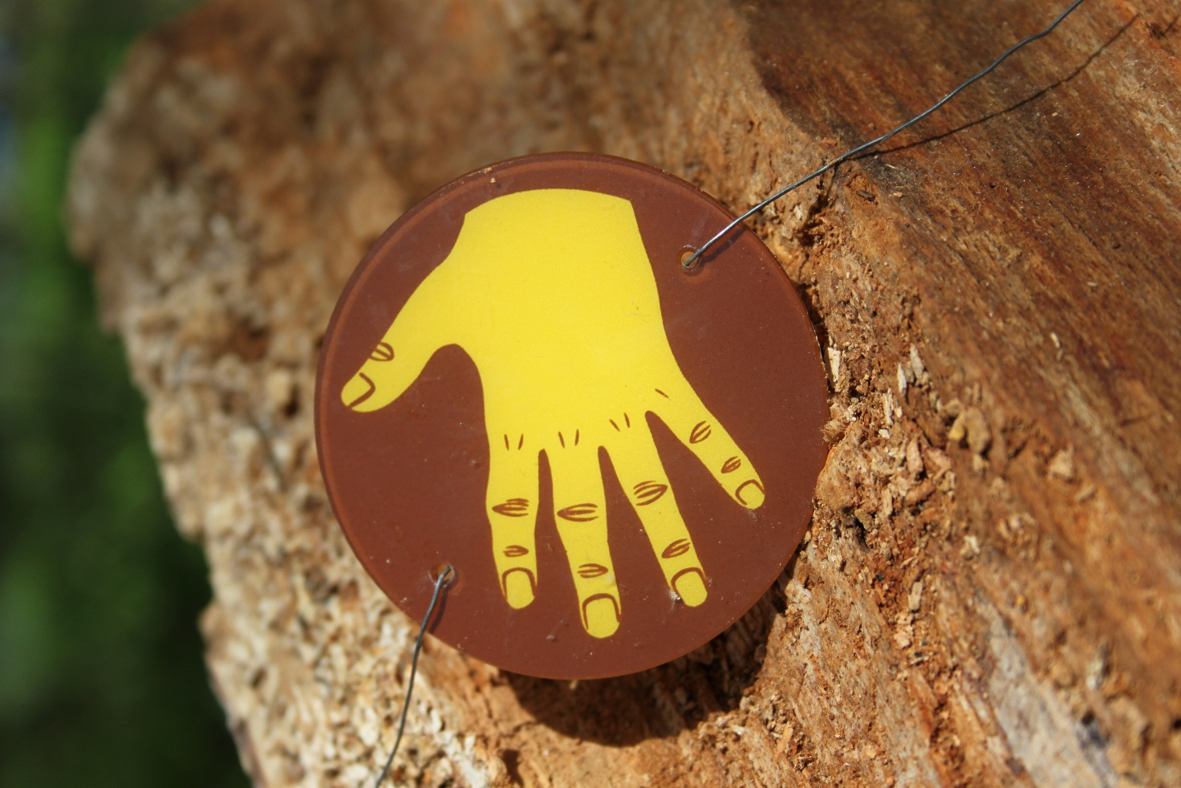
Figure 6: A marker with a hand on it representing touch. Photo ©Sensory Trust

This type of encouragement, permission, makes someone feel like you want them to be here. And want them to really be here, not just politely passing through a place, but to be getting up close and personal and to have a relationship with the place they are in. By inviting people in through their senses you will undoubtably make them more curious. They will have questions, opinions, maybe even concerns or ideas of help and change, all of which making this something they are part of, not merely a spectator.
Adding sensory layers
Sensory exploration can be supported by adding new objects and designs in the landscape. Sensory Trust’s work at the Wheal Martyn china clay mining museum in Cornwall is a good example. The addition of sensory benches provides important rest and pause opportunities for visitors. The inclusion of beautiful, tactile clay tiles to the arms and back of the bench provides a subtle invitation to engage with some of the wider sensory stories and experiences on offer.
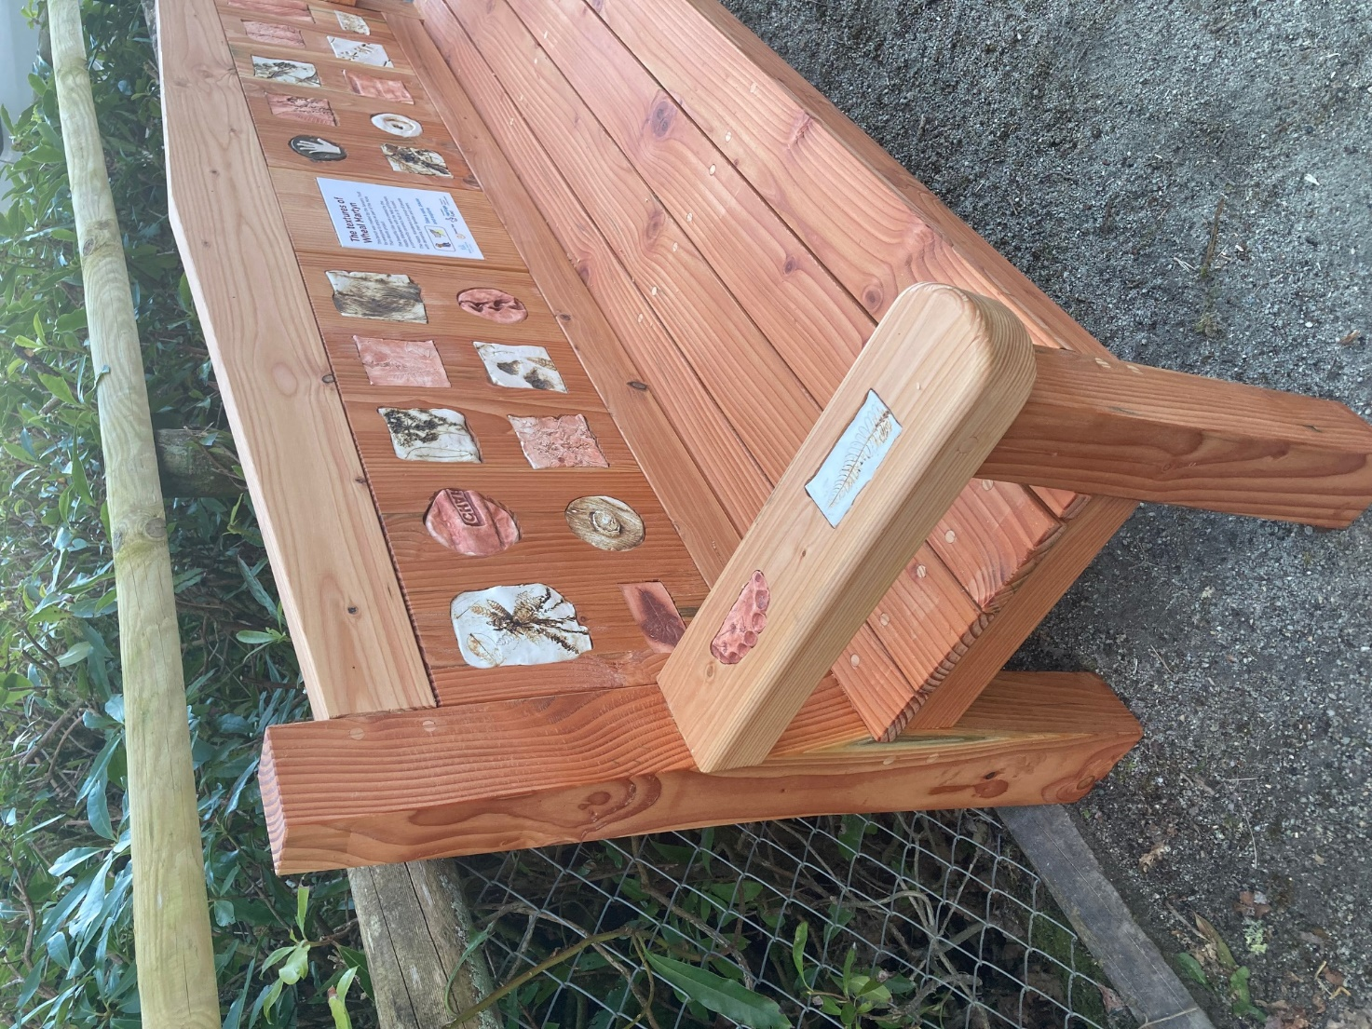

Figure 7: The sensory bench at Wheal Martyn Clay Works Museum with tactile tile panels running along its back and on the arm rests. Photo ©Sensory Trust

We differ in the ones that each of us can use, but all of us are incredible sensory investigators. And yet when we come to designing our environments, vision so often steals the show. How can we be so wonderfully sentient in our day to day lives, and yet fail to reflect that when it comes to creating the spaces and experiences that are supposed to engage us? Embracing the diversity of senses is an excellent way of embracing diversity of people. (Jane Stoneham, April 2021)

We can design and interpret our spaces to be technically accessible, but if we miss the opportunity to respond to the sentient make-up of human beings aren’t they unlikely to become the places and experiences we wish they were? (Jane Stoneham, April 2021)

Inclusive sensory narratives
Inclusive communication techniques are critical to ensuring that sensory stories and narratives are available to the widest diversity of people. Important considerations include how a visitor’s interests can be supported, where they can find answers, and whether they are in a format they can understand. The sharing of stories is one of the most important things, they bring benefits to us all, insights to places, times, and events. But those stories need to work for everyone.
This is rarely a one size fits all, more often several versions of the same narrative. Starting with the words that do the job of telling the story leads to creating the versions needed for each of the audiences expected.
Simplifying a story to create a symbol supported version or a ten-line sensory story has proved valuable for people with learning difficulties. Bringing stories to life through a multisensory approach. Delivering the story using sensory actions for example through scent, sound, and movement, strengthens the connection and understanding, allowing the audience to be part of the story. Using the whole body to understand a place, enables everyone to engage and be part of it. This lasts longer than a single sense approach and will encourage memories and appreciation of the story shared.
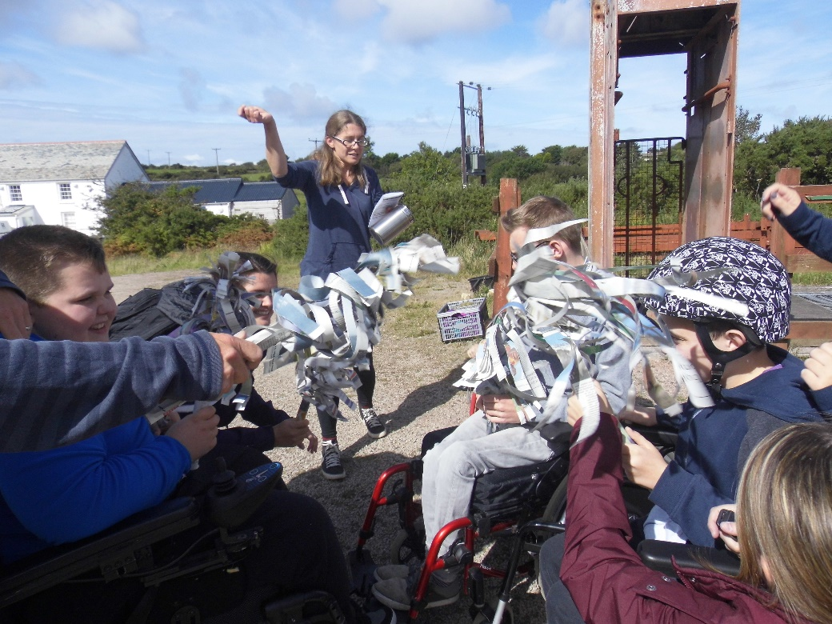
Figure 9: The creation of a sensory story in action, led by Lynsey Robinson of Sensory Trust at King Edward Mine. Photo ©Sensory Trust

Creating narratives using people’s primary languages and communication methods ensures that they can own their personal narrated experiences, rather than relying on someone else. For example, a story can be shared through braille. When the braille carries a non-visual interpretation, the impact can be especially rewarding. Similarly, narrating through British Sign Language (BSL) opens up the opportunity for Deaf BSL users to experience a historic landscape on their own terms.
Between a range of multisensory experiences and inclusive communication methods the landscapes and stories can be shared by anyone who is interested in them ensuring they live on and are celebrated by all.

Guiding questions for future work
This briefing has explored the potential for sensory history scholarship to disrupt and expand the types of stories shared about landscape; moving beyond dominant forms of landscape encounter to enable a greater diversity of people to ‘be’ and belong in historic landscapes.
We close by sharing a series of questions that people involved in historic landscape management and interpretation might consider when revisiting opportunities to share hidden or under-examined dimensions of historic landscape experience:
- Whose stories are currently told about the landscape?
- Who else might have been involved in the making, shaping and care of the landscape at different moments in time?
- Where might we find their stories? Can we find snapshots of their presence anywhere – in the landscape itself or in perhaps under-explored primary sources like letters, diaries, images, account books etc? What skills might these people have had? How might the landscape have imprinted on them through their specific forms of engagement?
- What forms of landscape encounter have been overlooked in prominent interpretation efforts? Perhaps hints within primary sources of how the landscape used to feel, smell, sound or even taste at different times of year. Is there scope to conduct oral histories to access some of these insights from the more recent past with key people?
- Who might these alternative stories resonate with today and in what ways?
- What tensions might such stories create and how can they be discussed in ways that are constructive and inclusive rather than polarising?
- How is landscape change depicted in the stories told? When is it useful to foreground stories of transformation and when do we look to those of stability? How can we learn from landscape histories to continue to care for and nurture landscapes as they evolve in the face of climate change?
- Are there new ways of sharing these stories – both in situ and through digital engagement? Moving beyond the interpretation board to facilitate more experiential ways of sensing, knowing and imagining landscape?
- Finally, can we rethink who is crafting and telling these stories? Forge new partnerships to ensure stories are shared in ways that resonate for people who might not otherwise feel welcome or at home in these settings?

Acknowledgements
With thanks to the following:
The Arts and Humanities Research Council for funding this work through grant AH/T006080/1 for the Unlocking Landscapes: History, Culture and Sensory Diversity in Landscape Use and Decision Making project; The Sensory Trust for providing advice and a real world example of how this can be applied; the input of our project Advisory Board; and the participants of the online ‘Whose Landscape?’ workshop held as part of the project in April 2021. Their thoughts and ideas were integral to developing this report.

References

Cronon, W. (1997) The Trouble with Wilderness; or, Getting Back to the Wrong Nature. In Cronon, W. (Ed) Uncommon Ground: Rethinking the Human Place in Nature. New York: W. W. Norton & Co.
Menatti, L. (2017) Landscape: from common good to human right. International Journal of the Commons, 11 (2): 641–683
Oxford English Dictionary. (2022) Landscape [online]. Available at: https://www.oed.com/view/Entry/105515?Rskey=buggpb&result=1 [accessed September 2022].
Ingold, T. (2011) Being Alive: Essays on Movement, Knowledge and Description. London: Routledge.
Lee Boggs, G., Kurashige, S. and Glover, D. (2012). The Next American Revolution: Sustainable Activism for the Twenty-First Century. Berkeley: University of California Press (p79).
Rice, C. and Mündel, I. (2018) Story-Making as Methodology: Disrupting Dominant Stories through Multimedia Storytelling. Canadian Sociological Association, 55(2): 211-231 (p220).
Poole, S. (2018) Ghosts in the Garden: locative gameplay and Historical interpretation from below. International Journal of Heritage Studies, 24(3): 300-314.
O’Reilly, C. (2019) The Greening of the City: Urban Parks and Public Leisure, 1840-1939. Abingdon: Routledge (p89).
Williamson, T. (2019) How Natural is Natural? Historical Perspectives on Wildlife and The Environment in Britain? Transactions of the Royal Historical Society, 29: 293-311.
Fowler, C. (2021) Green Unpleasant Land. Creative Responses to Rural England’s Colonial Connections. Leeds: Peepal Tree Press Ltd. See also useful articles about the work of Kew Gardens in this area - https://theconversation.com/director-of-science-at-kew-its-time-to-decolonise-botanical-collections-141070 and the National Trust - https://www.nationaltrust.org.uk/features/addressing-the-histories-of-slavery-and-colonialism-at-the-national-trust.
Das, S. and Lowe, M. (2018) Nature Read in Black and White: decolonial approaches to interpreting natural history collections. Journal of Natural Science Collections, 6: 4 ‐ 14.
Rishbeth, C. (2004) Ethno-cultural representation in the urban landscape. Journal of Urban Design, 9(3): 311-333.
Useful blog posts for further information about (a) Humphry Repton - https://georgemckay.org/humphry-repton-disabled-garden-designer/ and (b) Gertrude Jekyll - https://static1.squarespace.com/static/5787505e197aea2902e34f8e/t/5c8e628deb3931467864bc8d/1552835275291/BEYOND+THE+BOOTS+for+website+4+March+2019.pdf [both accessed September 2022].
For more information about the US National Park Service, please visit: https://www.nps.gov/subjects/tellingallamericansstories/disabilityhistory.htm [Accessed September 2022].
Apaydin, V. (Ed) (2020) Critical Perspectives on Cultural Memory and Heritage Construction, Transformation and Destruction. London: UCL Open Press (p309).
Williamson, T. (2019) How Natural is Natural? Historical Perspectives on Wildlife and The Environment in Britain? Transactions of the Royal Historical Society, 29: 293-311.
Hardy, A. and Cushing, N. (2017) A Sensory History of the Newcastle Asylum for Imbeciles and Idiots, 1871-1900. Journal of Australian Colonial History, 19: 139-160.
Werner-Thomas, H. (2022) Sensory Roadmaps: How to Capture Sensory Detail in an Interview and Why Doing So Has Exciting Implications for Oral History. The Oral History Review, 49(1): 97-115.
Poole, S. (2018) Ghosts in the Garden: locative gameplay and Historical interpretation from below. International Journal of Heritage Studies, 24(3): 300-314.
Rice, C. And Mündel, I. (2018) Story-Making as Methodology: Disrupting Dominant Stories through Multimedia Storytelling. Canadian Sociological Association, 55(2): 211-231 (p213).
Douglas, P., Rice, C. and Siddiqui, A. (2020) Living Dis/Artfully with and in illness. Journal of Medical Humanities, 41: 395-410.
Mykitiuk. R., Chaplick. A. and Rice, C. (2015) Beyond normative ethics: Ethics of arts-based disability research. Ethics, Medicine and Public Health, 1: 373-382 (p380).
Lauwrens, J. (2012) Welcome to the revolution: The sensory turn and art history. The Journal of Art Historiography, 7: 1-17.

